Task#1
You are tasked with implementing a dynamic matrix class in C++ that supports the following operations: Dynamic Matrix Creation: Create a dynamic 2D array (matrix) with rows and columns specified by the user. Matrix Resizing: Implement a method to resize the matrix. The new size should be provided as input (new rows and columns). If the new size is larger, initialize the new elements with a given value. If the new size is smaller, truncate the matrix. Matrix Transposition: Implement a method to transpose the matrix (rows become columns and vice versa). Matrix Printing: Implement a method to print the matrix. After add 2 to each odd index then print the array. Memory Deallocation: Ensure proper memory management, including deallocation of the dynamic matrix when no longer needed.
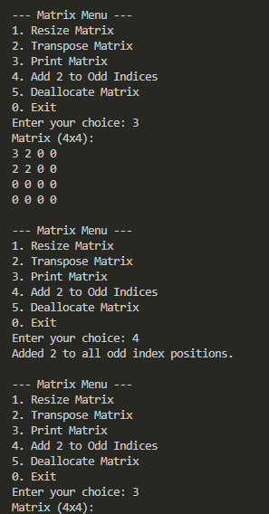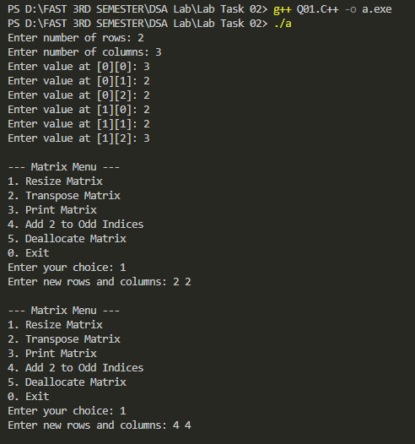

Task#2
A school has conducted exams for 5 students in 4 subjects.
You are required to:
• Use a appropriate dynamic array to store marks.
• Calculate and display:
• Total marks of each student.
• Average marks of each subject.
• The topper student (highest total marks).
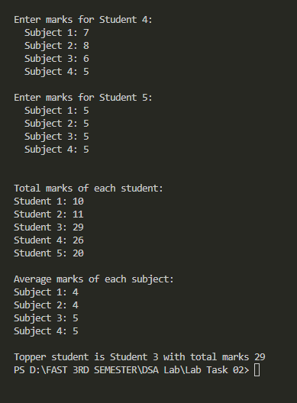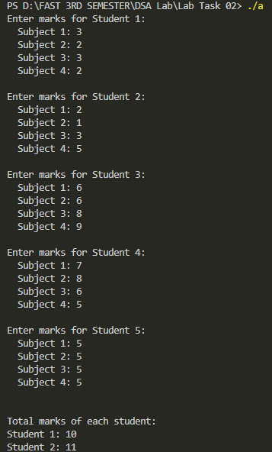
Task#3
A university is managing the marks of students in multiple subjects. Each department has a
different number of students. Each student has marks for a fixed number of 5 subjects.
You need to store this data in a appropriate dynamic array where rows = number of departments
and columns = number of students in each department. Then, calculate the highest, lowest and
average marks of each department and display them.
#include <iostream>
#include <iomanip>
using namespace std;

int main() {
int departments;
cout << "Enter number of departments: ";
cin >> departments;

// Create a jagged array for departments
int*** marks = new int**[departments]; // 3D: dep students subjects
int* students = new int[departments];

//Input student counts and marks
for (int d = 0; d < departments; d++) {
cout << "\nEnter number of students in department " << d + 1 << ": ";
cin >> students[d];

// Allocate memory for students in this department
marks[d] = new int*[students[d]];

// Each student has marks in 5 subjects
for (int s = 0; s < students[d]; s++) {
marks[d][s] = new int[5];
cout << "Enter 5 subject marks for student " << s + 1 << " of Dept " << d + 1 << ": ";
for (int subj = 0; subj < 5; subj++) {
cin >> marks[d][s][subj];
}
}
}

// Calculate highest, lowest, and average for each department
cout << fixed << setprecision(2);
for (int d = 0; d < departments; d++) {
int highest = -1e9, lowest = 1e9;
double sum = 0;
int totalMarks = students[d] * 5;

for (int s = 0; s < students[d]; s++) {
for (int subj = 0; subj < 5; subj++) {
int m = marks[d][s][subj];
if (m > highest) highest = m;
if (m < lowest) lowest = m;
sum += m;
}
}

double avg = (totalMarks > 0) ? (sum / totalMarks) : 0;

cout << "\nDepartment " << d + 1 << " Results:\n";
cout << "Highest Mark: " << highest << endl;
cout << "Lowest Mark: " << lowest << endl;
cout << "Average Marks: " << avg << endl;
}

// Step 4: Deallocate memory
for (int d = 0; d < departments; d++) {
for (int s = 0; s < students[d]; s++) {
delete[] marks[d][s];
}
delete[] marks[d];
}
delete[] marks;
delete[] students;

return 0;
}

